Ryan Colaco, Leslie Moore, Melanie Plattner

Project 1: Database Design, Creation, & Queries

1. Relational Database Design

Our team members for this project are Ryan Colaco, Leslie Moore, and Melanie Plattner.

The company we have selected is Uber. Uber Technologies Inc. is an online [transportation](https://en.wikipedia.org/wiki/Transportation_network_company) network and platform that develops, markets and operates the Uber mobile "[app](https://en.wikipedia.org/wiki/Software_application)". This app allows consumers to submit a trip request. When a request is submitted, the nearest Uber driver is automatically notified, alerting the driver to the location of the customer. Uber drivers use their own personal cars for this, and they get paid the trip fare from the consumer. Uber then receives a small percentage of the fare as a fee. As of August 2016, the service was available in over 66 countries and 507 cities worldwide. The Uber app automatically calculates the fare and transfers the payment to the driver.

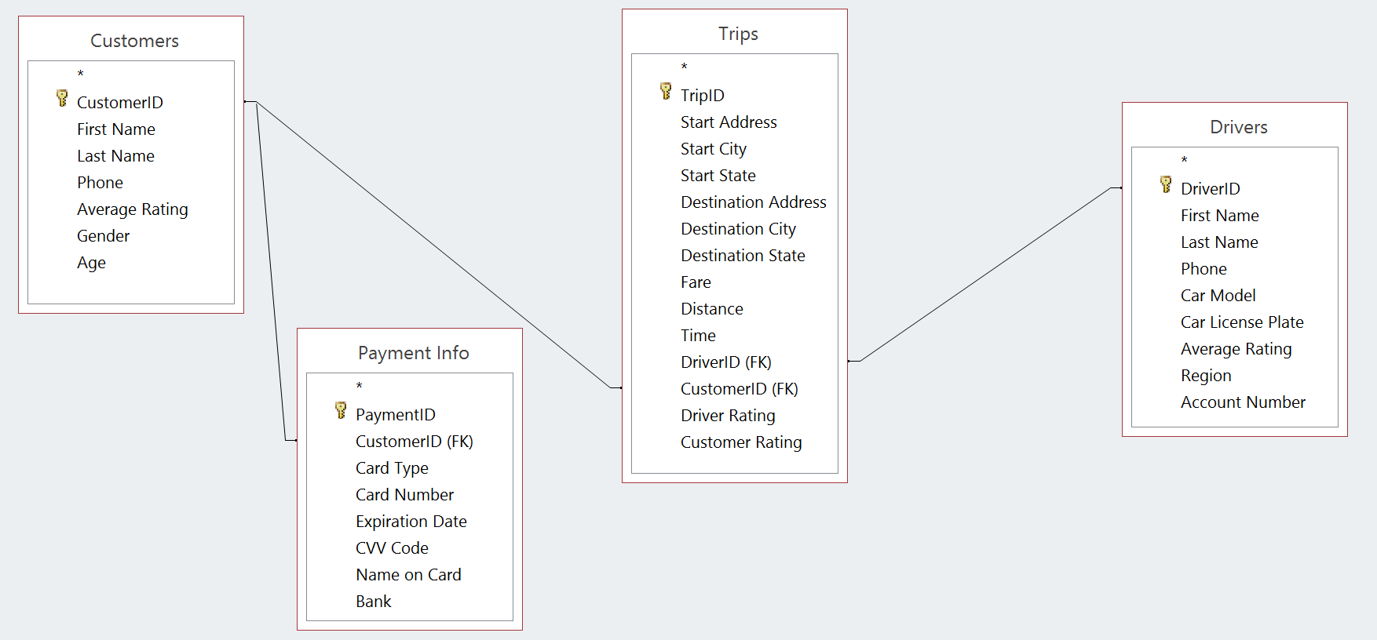

(miles)

(min)

M

M

M

1

1